%DIFFERENTIAL EQUATIONS LAB 6

%Exercise 1

% part(a)

The period of oscillation is about 4.49 seconds. Since ω is less than ω0, the first part of the piecewise equation is used. This equations returns: α = 0.6015 radians.

% part(b)

function LAB06ex1

clc

omega0 = 2; c = 1; omega = 1.4;

alpha=0.601455;

param = [omega0,c,omega];

t0 = 0; y0 = 0; v0 = 0; Y0 = [y0;v0]; tf = 50;

options = odeset('AbsTol',1e-10,'relTol',1e-10);

[t,Y] = ode45(@f,[t0,tf],Y0,options,param);

y = Y(:,1); v = Y(:,2);

t1 = 25; i = find(t>t1);

C = (max(Y(i,1))-min(Y(i,1)))/2;

y=y-C\*(cos(omega\*t-alpha))

disp(['computed amplitude of forced oscillation = ' num2str(C)]);

Ctheory = 1/sqrt((omega0^2-omega^2)^2+(c\*omega)^2);

disp(['theoretical amplitude = ' num2str(Ctheory)]);

figure(1)

plot(t,y,'b-'); ylabel('y'); grid on;

%----------------------------------------------------------------

function dYdt = f(t,Y,param)

y = Y(1); v = Y(2);

omega0 = param(1); c = param(2); omega = param(3);

dYdt = [ v ; cos(omega\*t)-omega0^2\*y-c\*v ];

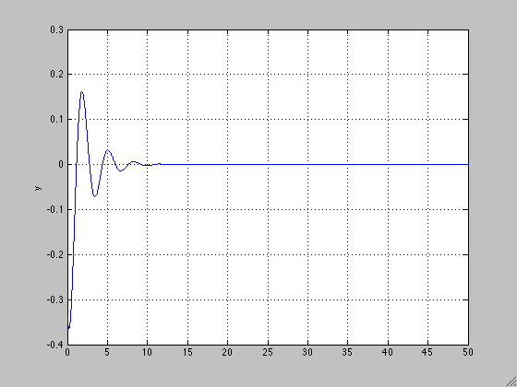

Yes, the oscillations appear to be decreasing exponentially and this is because the complementary solution describes the discrepancy between the actual oscillations and the force oscillation. Since the oscillations are quiclky forced to the specified oscillation equation, the discrepancy doesn’t last long.

%Exercise 1

% part(a)

function LAB06ex2

omega0 = 2; c = 1;

OMEGA = 1:0.02:3;

C = zeros(size(OMEGA));

Ctheory = zeros(size(OMEGA));

t0 = 0; y0 = 0; v0 = 0; Y0 = [y0;v0]; tf = 50; t1 = 25;

for k = 1:length(OMEGA)

omega = OMEGA(k);

param = [omega0,c,omega];

[t,Y] = ode45(@f,[t0,tf],Y0,[],param);

i = find(t>t1);

C(k) = (max(Y(i,1))-min(Y(i,1)))/2;

Ctheory(k) = 1/sqrt((omega0^2-omega^2)^2+(c\*omega)^2); % FILL-IN

end

figure(2)

plot(OMEGA,Ctheory,'k-',OMEGA,Ctheory,'ro'); grid on; % FILL-IN

xlabel('\omega'); ylabel('C');

%---------------------------------------------------------

function dYdt = f(t,Y,param)

y = Y(1); v = Y(2);

omega0 = param(1); c = param(2); omega = param(3);

dYdt = [ v ; cos(omega\*t)-omega0^2\*y-c\*v ];

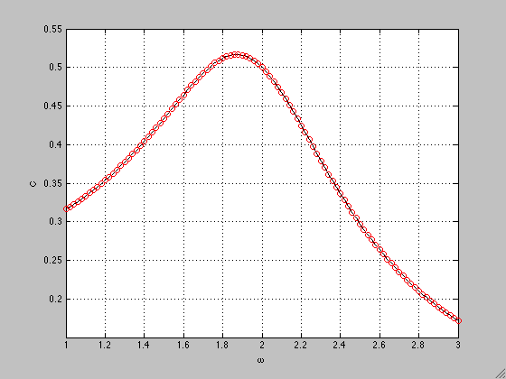

% part(b)

The approximate value of OMEGA that returns the maximum of the graph is ~1.8733. The corresponding value of C is 0.5167. 1.8733 is the practical resonance frequency.

% part(c)

syms W;

f(W)= 1/sqrt((omega0^2-W^2)^2+(c\*W)^2);

y=diff(f);

z=solve(y)

f(z)

Result in command window:

z =

0

14^(1/2)/2

-14^(1/2)/2

ans =

1/4

(2\*15^(1/2))/15

(2\*15^(1/2))/15

This means that the zero of the function is at omega=14^(1/2)/2 or 1.871 which returns a value of C of (2\*15^(1/2))/15 or 0.5164. This analytical value of omega is slightly less than the approximation made in part b.

% part(d)

Graph from ex1 with omega= 14^(1/2)/2

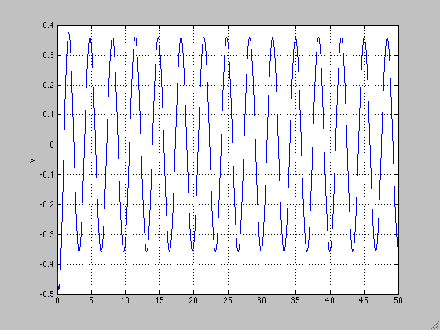From the graph, the amplitude is about 0.36, which is slightly less than it was in part 1. As omega increases, the amplitude will decrease.

% part(e)

As the initial condition c was increased, the amplitude of the graph decreased. As the initial condition ω0 was increased, the initial amplitude was increased but the amplitude of the forced oscillation was the same. From the equation, these changes make sense. Because c is in the denominator, it makes sense that a larger c value would decrease the amplitude. And since ω0 determines the initial oscillations it makes sense that it would initially increase until it is damped to the forced oscillation.

%Exercise 3

% part(a)

c=0

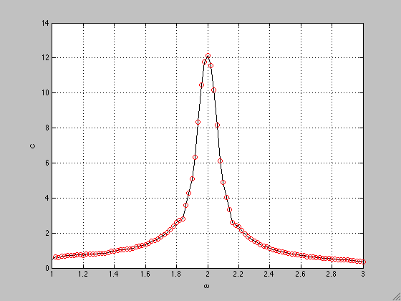

maximal amplitude= 12.15

pure resonant frequency= 2

ω= ω0=2

% part(b)

c=0; ω0= 14^(1/2)/2

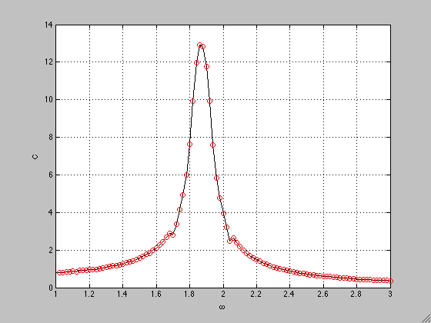

amplitude increased to 12.9

ω decreased to 1.86

%Exercise 4

%part(a)

function LAB06ex1

clc

omega0 = 2; c = 0; omega = 1.8;

param = [omega0,c,omega];

t0 = 0; y0 = 0; v0 = 0; Y0 = [y0;v0]; tf = 100;

options = odeset('AbsTol',1e-10,'relTol',1e-10);

[t,Y] = ode45(@f,[t0,tf],Y0,options,param);

y = Y(:,1); v = Y(:,2);

C = 1/(omega0^2-omega^2);

A=2\*C\*sin(.5\*(omega0-omega)\*t);

figure(1)

plot(t,y,'b-',t,A,'r',t,-A,'g'); grid on;

t1 = 25; i = find(t>t1);

disp(['computed amplitude of forced oscillation = ' num2str(C)]);

Ctheory = 1/sqrt((omega0^2-omega^2)^2+(c\*omega)^2);

disp(['theoretical amplitude = ' num2str(Ctheory)]);

%----------------------------------------------------------------

function dYdt = f(t,Y,param)

y = Y(1); v = Y(2);

omega0 = param(1); c = param(2); omega = param(3);

dYdt = [ v ; cos(omega\*t)-omega0^2\*y-c\*v ];

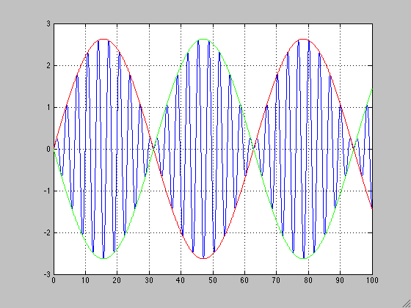

%part(b)

The period of fast oscillation from the equation is 62.83s. This is confirmed by the graph:

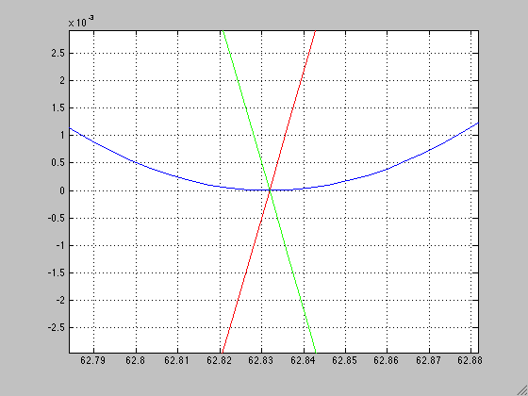

It can be observed that the lines pass the zero at the end of one period at about t=62.832s.

%part(c)

Analytical solution of the length of the graph using the equation 2π/( ω0- ω) = 31.42s. This value is confirmed by the graph:

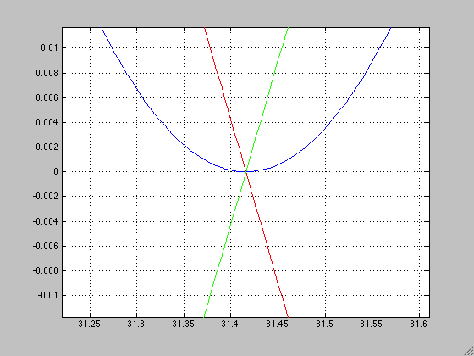

As seen from the graph the first intersection after t=0 is at t= 31.42s.

%part(d)

ω =1.9

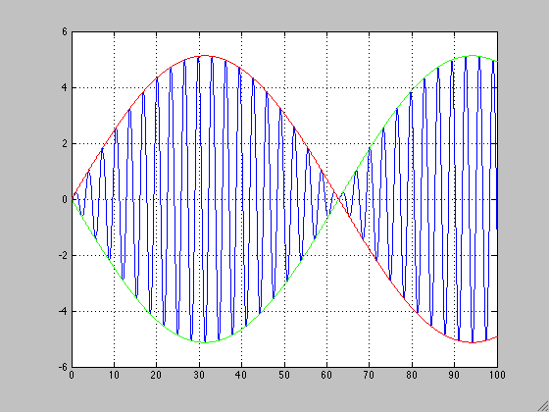

When omega is changed to 1.9, the period of fast oscillation increases to 125.664s and the length of the beats increases to 62.83s. These values are double the values from the last graph.

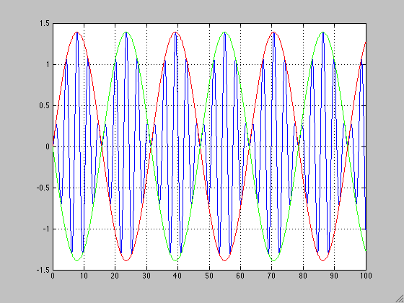 ω = 1.6

When omega is changed to 1.6, the period of fast oscillation decreases to 31.42s and the length of the beats decreases to 15.71s and these values are half of the original values from the graph where ω = 1.8

%part(e)

ω = 0.5

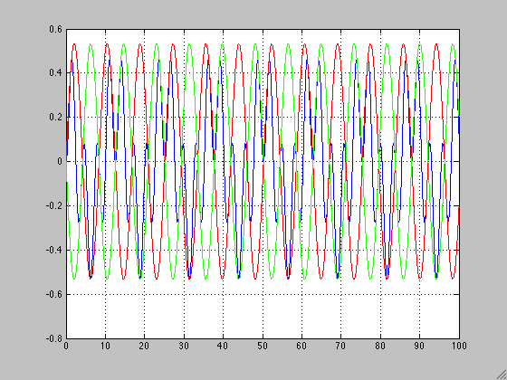

When ω is decreased to 0.5, the beats phenomenon no longer exists and the envelope functions no longer surround the oscillations of the graph. This happens because ω is decreased so much that it decreases the period as well.